Running and using the application

-Locate and open “WpfApp2.sln”



-wait for files to download and render

-click “ctrl +b” to build the file.

-next click start to start running the application 

-this is the beautiful interface that will pop up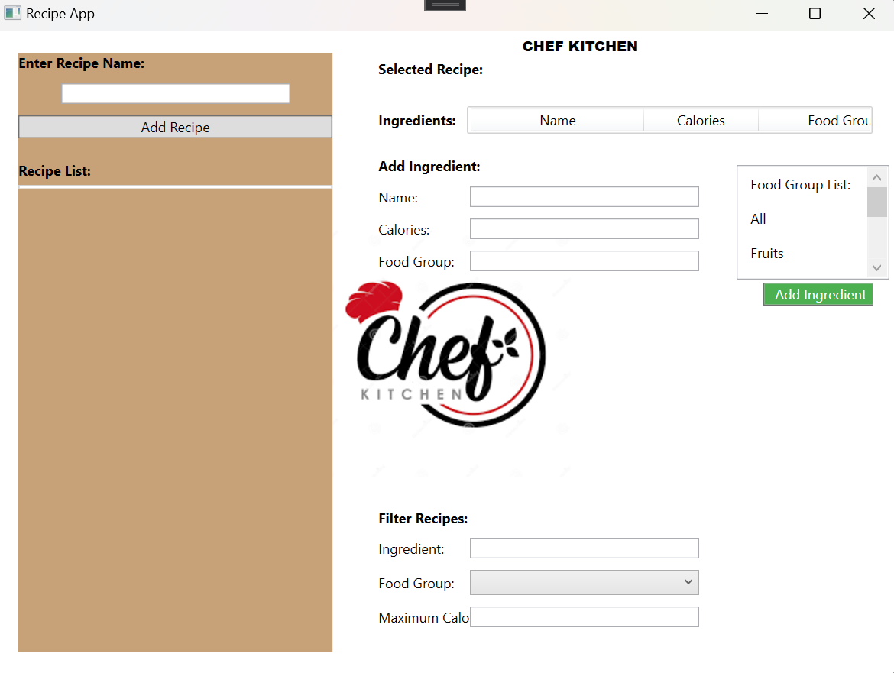

-Enter recipe details starting from the name

-Click “Add Recipe”

-Recipe List will populate

The next step is to add ingredients to the existing Recipe List

-select the recipe you just added

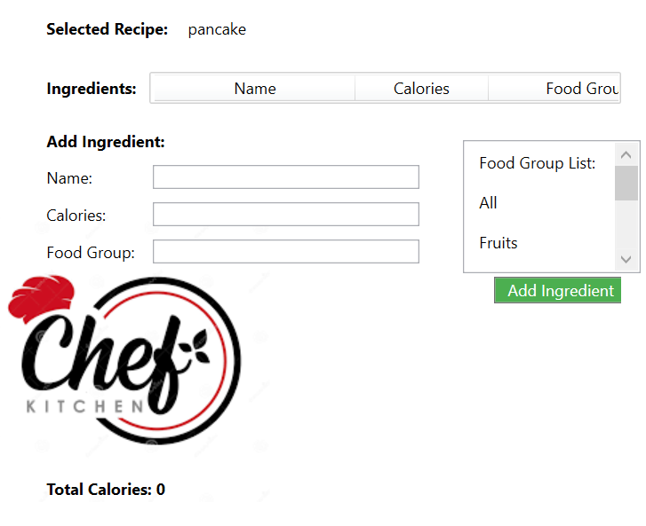

Now add ingredients to that recipe

And click “Add Ingredient”

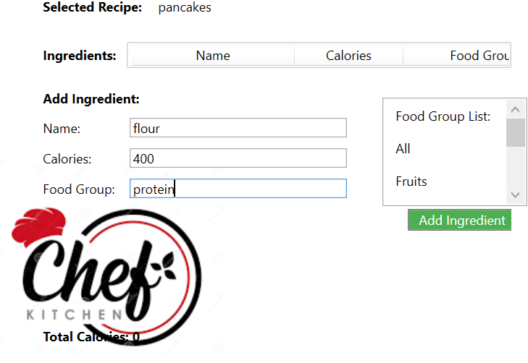

-since the Calories exceed 300, A warning message will appear telling you that you have exceeded 300 calories

This is what you will see after clicking ok

This is what you will see after entering another ingredient

this is what you will see when you try to filter recipes using ingredients. You can also filter recipes using calories

